Circle Language Spec: Execution Control

Exit Loop in a Diagram
The concept of Exit Loop was explained the article Exit Loop. The current article only explains its expression in a diagram.

The Exit Loop command is displayed inside the clause that is looped as a jump to the Command End of the whole loop.

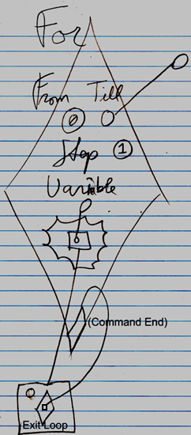

The text Command End is not required in the diagram:

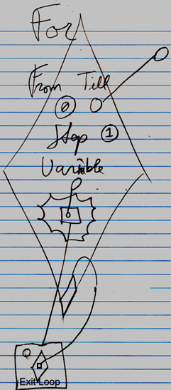

See also: Exit Loop

Author & Copyright: Jan-Joost van Zon Date: June 11, 2008 – June 11, 2008 Location: Oosterhout, The Netherlands Status: Finished

